**SRM INSTITUTE OF SCIENCE & TECHNOLOGY**

**DEPARTMENT OF ECE**

**FACULTY OF ENGINEERING AND TECHNOLOGY**

**LESSON PLAN**

**ACADEMIC YEAR: 2023 - 24 SEMESTER: III**

**TOTAL HOURS: L - 45 Hrs**

|  |  |  |  |  |  |  |  |  |  |  |
| --- | --- | --- | --- | --- | --- | --- | --- | --- | --- | --- |
| **Course Code** | 21ECC201J | **Course Name** | Solid State Devices | **Course Category** | C | Professional Core | L | T | P | C |
| 2 | 0 | 2 | 3 |

| **Session** | **Topic** | **Mode of Teaching** |  |
| --- | --- | --- | --- |
| Unit I - SEMICONDUCTOR JUNCTION THEORY | | | |
|  | Semiconductor: Fermi level, Electron and hole concentration at equilibrium | PPT | 1,2,4,5 |
|  | Temperature dependence of charge carrier, Drift and diffusion of carriers | PPT | 1,2,4,5 |
|  | Hall effect. | PPT | 1,2,4,5 |
|  | PN junction theory: Current-Voltage relationship, | PPT | 1,2,4,5 |
|  | Calculation of depletion width, potential barrier, diode current, | PPT | 1,2,4,5 |
|  | Capacitive effects in PN junction, Energy band structure, | PPT | 1,2,4,5 |
|  | PN diodes: Terminal characteristics and parameters, | PPT | 1,2,4,5 |
|  | Diode modelling | PPT | 1,2,4,5 |
|  | DC load line and analysis | PPT | 1,2,4,5 |
| **Unit II -** SPECIAL JUNCTION DIODES AND PN APPLICATIONS | | | |
|  | Zener diode, Varactor diode | PPT | 1,2,4,5 |
|  | Step recovery diode, Tunnel diode | PPT | 1,2,4,5 |
|  | LED, Laser diode, | PPT | 1,2,4,5 |
|  | Pin photodiode, Avalanche Photodiode. | PPT | 1,2,4,5 |
|  | Half wave rectifier- Operation and derivation of average values of output voltage and current, ripple factor and efficiency, Peak inverse voltage, Transformer Utilization factor | PPT | 1,2,4,5 |
|  | Full wave rectifier: Center tapped - Operation and derivation of average values of output voltage and current, ripple factor and efficiency, Peak inverse voltage, Transformer Utilization factor | PPT | 1,2,4,5 |
|  | Bridge rectifier: Operation and derivation of average values of output voltage and current, ripple factor and efficiency, Peak inverse voltage, Transformer Utilization factor. | PPT | 1,2,4,5 |
|  | Filters: Inductor and capacitor filters, LC and CLC Filters, | PPT | 1,2,4,5 |
|  | Clippers and Clampers, Voltage Multipliers | PPT | 1,2,4,5 |
| **Unit III -** BIPOLAR JUNCTION TRANSISTOR | | | |
|  | Physical structure and device operation of BJT | PPT | 2,3,5,6 |
|  | Current-Voltage characteristics of BJT configurations, Early effect [CE, CB] | PPT | 2,3,5,6 |
|  | Current-Voltage characteristics of BJT configurations [CC] | PPT | 2,3,5,6 |
|  | BJT circuit models: Ebers Moll, Gummel Poon | PPT | 2,3,5,6 |
|  | BJT circuit models: Small signal & Hybrid-π | PPT | 2,3,5,6 |
|  | Biasing circuits for BJT: Base bias, Emitter bias | PPT | 2,3,5,6 |
|  | Biasing circuits for BJT: Voltage-divider bias, Collector-feedback bias | PPT | 2,3,5,6 |
|  | BJT as an amplifier as a switch | PPT | 2,3,5,6 |
|  | BJT as a switch | PPT | 2,3,5,6 |
| **Unit IV** - FIELD EFFECT TRANSISTOR | | | |
|  | Physical Structure, Device operation and I-V characteristics of DE-MOSFET | PPT | 2,3,5,6 |
|  | Physical Structure, Device operation and I-V characteristics of E-MOSFET | PPT | 2,3,5,6 |
|  | Derivation drain current and  Transconductance | PPT | 2,3,5,6 |
|  | Biasing circuits for MOSFET: Gate bias, Self-bias | PPT | 2,3,5,6 |
|  | Biasing circuits for MOSFET: Voltage divider bias | PPT | 2,3,5,6 |
|  | MESFET, HEMT, CMOSFET | PPT | 2,3,5,6 |
|  | MOSFET as an amplifier, MOSFET  as a switch, | PPT | 2,3,5,6 |
|  | FET Models | PPT | 2,3,5,6 |
| 9 | Problem solving | PPT | 2,3,5,6 |
| **Unit V -** FABRICATION OF SEMICONDUCTOR DEVICES | | | |
|  | Integrated Circuit: Advantages, Limitations, Classification. | PPT | 1,5 |
|  | Integrated Circuit: Classification | PPT | 1,5 |
|  | IC Manufacturing: Material Preparation | PPT | 1,5 |
|  | Crystal Growing and wafer preparation | PPT | 1,5 |
|  | Wafer fabrication, Testing | PPT | 1,5 |
|  | Bonding and Packaging | PPT | 1,5 |
|  | Fabrication of PN diode | PPT | 1,5 |
|  | Fabrication of BJT | PPT | 1,5 |
|  | Fabrication of MOSFET | PPT | 1,5 |

**Reference Books:**

1. Ben G. Streetman and Sanjay Kumar Banerjee, “Solid State Electronic Devices”, Pearson, 7th edition, 2016.
2. Donald A Neamen, Dhrubes Biswas “Semiconductor Physics and Devices”, 4th edition, McGraw-Hill Education, 2012.
3. Robert L. Boylestad and Louis Nashelsky, “Electronic Devices and Circuit Theory”, Pearson Education, 11th Edition, 2013.
4. R. S. Sedha, “Applied Electronics”, S. Chand, 2018.
5. David A. Bell, “Electronic Devices and Circuits”, 5th edition, Oxford University Press, 2015.
6. Muhammad Rashid, “Microelectronic Circuits: Analysis & Design”, 2nd edition, Cengage Learning, 2010.
7. Thomas L. Floyd, “Electronic Devices”, Pearson, 9th edition, 2013

**Assessment Procedure:**

|  |  |  |  |
| --- | --- | --- | --- |
| **CLO** | **Continuous Learning Assessment** | **Internal mark weightage (50)** | |
| **Theory (45)** | **Practice (15)** |
| CLO1 | CLA1 | 5 | 5 |
| CLO2 |
| CLO3 | CLA2 | 7.5 | 7.5 |
| CLO4 |
| CLO5,6 | CLA3 | 7.5 | 7.5 |
| CLA4 | 5 | 5 |

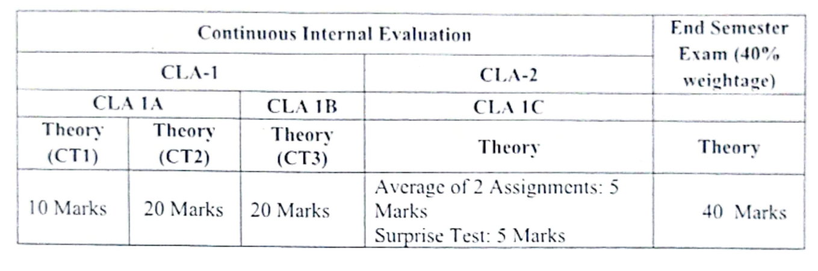

**SRM INSTITUTE OF SCIENCE & TECHNOLOGY**

**DEPARTMENT OF ECE**

**FACULTY OF ENGINEERING AND TECHNOLOGY**

**Course Articulation Matrix**

|  |  |  |  |  |  |  |  |  |  |  |  |  |  |  |  |  |
| --- | --- | --- | --- | --- | --- | --- | --- | --- | --- | --- | --- | --- | --- | --- | --- | --- |
| CO | At the end of this course, learners will be able to: | **Program Outcomes** | | | | | | | | | | | | **PSOs** | | |
| **1** | **2** | **3** | **4** | **5** | **6** | **7** | **8** | **9** | **10** | **11** | **12** | **1** | **2** | **3** |
| *CO-1:* | Comprehend the basic properties of semiconductors and PN junction. | *3* | *2* | *-* | *-* | 1 | *-* | *-* | *-* | *-* | *-* | *-* | - | 1 | - | - |
| *CO-2:* | Analyze and experiment applications of special diodes and PN diode. | *3* | *2* | *-* | *-* | 1 | *-* | *-* | *-* | *-* | *-* | *-* | - | 1 | - | - |
| *CO-3:* | Articulate the construction, operation, characteristics and parameters of Bipolar Junction transistor and its applications | *3* | *2* | *-* | *-* | 1 | *-* | *-* | *-* | *-* | *-* | *-* | - | 1 | - | - |
| *CO-4:* | Demonstrate construction, operation, characteristics and parameters of Field Effect Transistor and its application. | *3* | *2* | *-* | *-* | 1 | *-* | *-* | *-* | *-* | *-* | *-* | - | 1 | - | - |
| *CO-5:* | Explain the fabrication techniques of semiconductor devices in integrated circuits. | *3* | *2* | *-* | *-* | *-* | *-* | *-* | *-* | *-* | *-* | *-* | *1* | 1 | - |  |